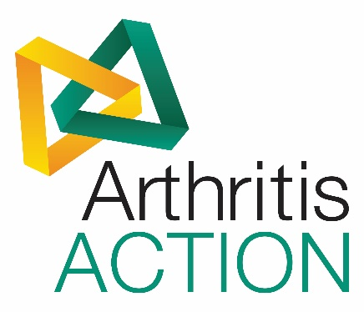

**ARTHRITIS ACTION**

**COMMUNICATIONS EXECUTIVE**

**JOB DESCRIPTION**

**Reporting to: Senior Communications Officer**

**Location: Victoria, London**

**Hours: Full-Time (37½ hours per week)**

**Salary: £22,000 - £24,000 (pro-rata)**

**Purpose: To support the Communications team with implementing Arthritis Action’s marketing and communications activities to raise the Charity’s profile and increase public awareness of arthritis. The ideal candidate will have experience in marketing, PR, and social media.**

**This is a fixed-term 3-month contract from mid-August – mid-November 2019.**

**Key Responsibilities**

* To conduct media research and populate the Charity’s media and advertising contact database.
* To support the Communications team with delivering their World Arthritis Day campaign on social media, in coordination with the Senior Communications Officer.
* To contact Arthritis Action’s members in key regions to populate the Charity’s case study database.
* To monitor press coverage about arthritis and Arthritis Action, and follow the news agenda.
* To promote the Charity’s events and Group meetings via social media and the website.
* To assist the Communications team with developing infographics using free web tools.
* To pitch stories to the local press to advertise Group meetings taking place from Sept-Dec.
* To pull out key themes from Arthritis Action’s Market Research report in August for the local, regional and national press.
* To expand the Charity’s photo library for the bi-annual magazine, e-newsletters and impact report.
* Working with the Communications Officer, to update web content using WordPress.
* To investigate low-cost video production options for Arthritis Action.
* To assist the Communications team with the content and production of the bi-annual magazine and monthly e-newsletter.
* Working with the Communications Director, to track marketing, communications and social media KPIs for the Board of Trustees’ reports.
* To assist with the content and production of the Charity’s annual impact report.
* To work with the Communications team on media and communications planning for the following year.

**Person Specification – Essential**

* Degree level qualification or equivalent – preferably in a Communications or related field.
* At least 2 years’ experience of working in the field of Communications and Marketing, and able to demonstrate knowledge of a broad range of communications activities – media, websites, publications, marketing, social media, PR, etc.
* Excellent oral and written communication skills.
* Experience of working with websites and producing website and digital content.
* Experience of using/managing social media platforms.
* Excellent organisational & interpersonal skills.
* Computer literate with good MS Office skills.
* Commitment to Arthritis Action’s vision, mission and brand values.
* An understanding of, and commitment to, equal opportunities and diversity – and the commitment to promote high standards of conduct, integrity and probity.

**Person Specification – Desirable**

* Knowledge of website content management systems and mass e-marketing tools.
* Database experience.
* Experience of working for a charity or not-for-profit organisation.
* Experience of working with e-communications, including preparing and sending E-Bulletins, etc.